99 Math Week 7 (May 25-29)--Mr. K. Gallagher
This week you will finish your exploration of exponents. We will start by using the Khan Academy site once again to watch some short clips on the topics right below those you worked on last week under the “Exponents” tab at https://www.khanacademy.org/math/pre-algebra/pre-algebra-exponents-radicals.
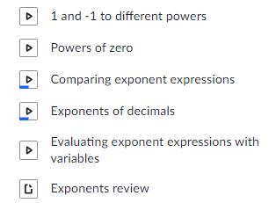
There is also a good quiz at the end of those Khan Academy links that might be useful to see how well you’ve really learned the material from last week and this week.
Once you’ve completed those, then it’s time to play a couple games to have a little fun with exponents. Try some of these...
http://www.mathgametime.com/games/otter-rush-exponents-game
https://mrnussbaum.com/exponents-online
http://www.xpmath.com/forums/arcade.php?do=play&gameid=95

Enjoy the week! It’s supposed to be a hot one.

